**(Module HTML-5)**

**Question 1.** What are the new tags added in HTML5? **Answer:** HTML5 introduced 5 most popular media element tags i.e.

<audio>, <video>, <source>, <embed>, <track>.

**Question 2.** How to embed audio and video in a webpage? **Answer:** To embed audio and video in a webpage, you can use the HTML <audio> and <video> elements.

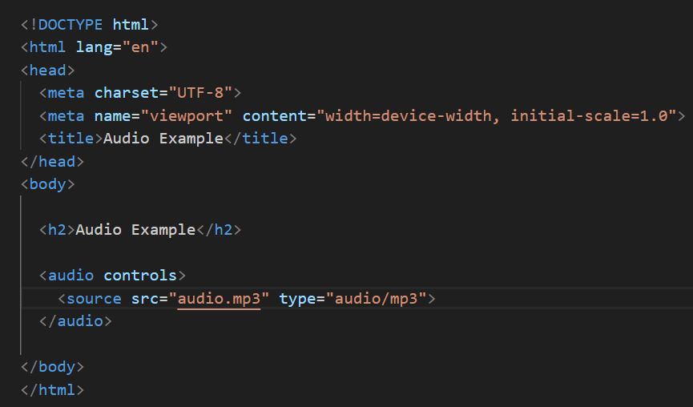

In this example, the <audio> element includes the controls attribute, which adds play, pause, and volume controls to the audio player. The <source> element inside the <audio> element specifies the source file and its type.

* **Video Tag:-**

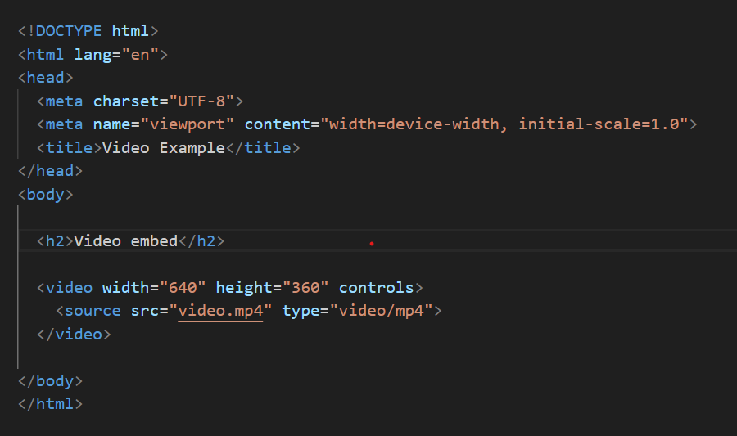

The <video> element includes the controls attribute for playback controls. The <source> element specifies the source file and its type.

**Question 3.**Semantic element in HTML5?

**Ans:-**Semantic element in html5.

**Ex:-**

* **Section:-** The <section> tag in HTML is a semantic element that represents a thematic grouping of content within a document. It is typically used to divide the content of a webpage into distinct sections.

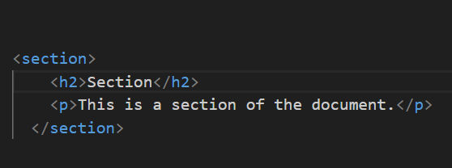

* **Video:-** The <video> tag in HTML is used to embed video content in a web page. It allows you to include video files directly within your HTML document.

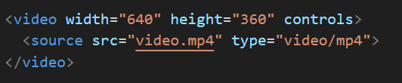

**aside:-** The <aside> tag in HTML is used to define content that is tangentially related to the content around it, often represented as a sidebar or a section containing related information.

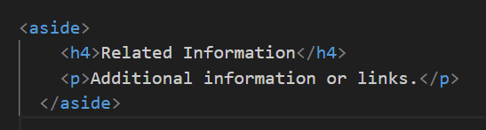

**article:-** Represents an independent piece of content that can be reused and distributed.

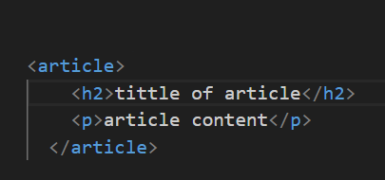

**Question 4.**Canvas and SVG tags. The <canvas> and <svg> elements in HTML are used for drawing graphics, but they have different approaches and use cases.

**Canvas:-**

The <canvas> element provides a bitmap-based drawing surface that can be manipulated using JavaScript. It's suitable for dynamic and interactive graphics.

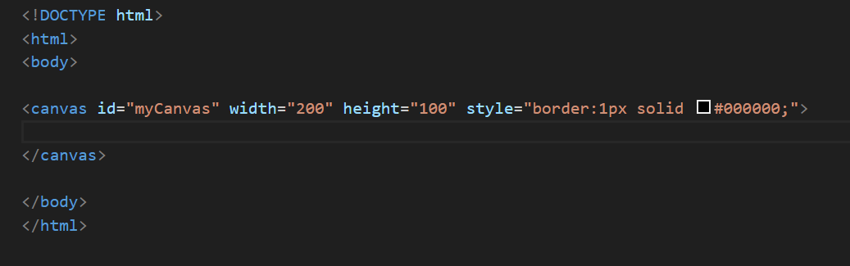

**Svg:-** The <svg> element, on the other hand, is a vector-based graphics format. It's ideal for static and scalable graphics, and the elements within <svg> are part of the DOM, making them easy to manipulate with CSS and JavaScript.

